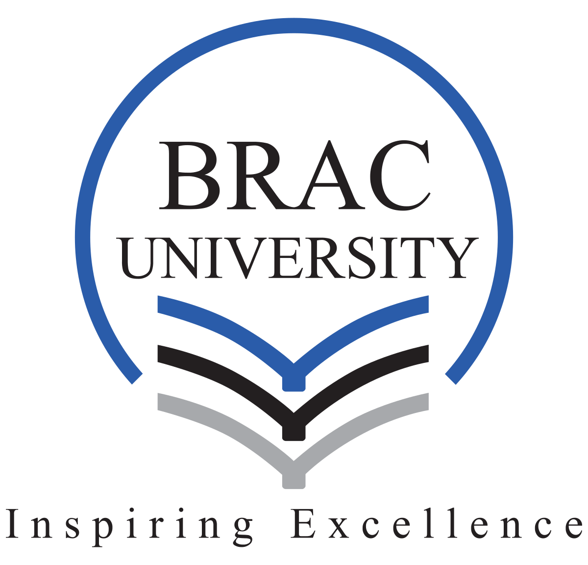

HRM620 TERM PAPER
An Analysis of Inclusive HR Practices and Technological Adaptation at Microsign

Submitted by
Group 4

HRM620 Section: 2
Submission Date: 3rd May 2026

Group Members:
NAME | ID
Raisul Islam Opu | 24341319
Md Rifat Rahman | 1000054675
MD Showrav Zaman | 1000055235
Mehbub Shifat Ur Rasul | 1000055399
Md. Amir Nasir | 23364002

Table of contents
Group Members: 1
Table of contents 2
1. Introduction 3
2. Organizational & Industry Context 4
3. Problem Statement (Critical Issue Identification) 5
4. Solution(s) highlighted in the Case Study to Solve the Problem 5
5. Recommend Alternative Solutions 6
5.1 Build Accessibility into the Machine Selection Process 7
5.2 Create a Structured Peer Training Program for the Technology Shift 7
5.3 Roll Out Technology in Stages, Not All at Once 7
5.4 Document and Preserve the Inclusive HR Model Formally 8
6. Conclusion 8
7. References (APA) 9

1. Introduction
Microsign Products is one of the finest examples of inclusive employment especially at a time when there will be greater pressure on businesses to prove that they not only perform well financially but also have a positive impact on society. Microsign Products - Founded in 1979 by Nisheeth P. Mehta at Bhavnagar (Gujarat) and is a proprietary firm involved with making electrical electronics & auto components. The company gradually diversified into parts related to aerospace, shipbuilding and power plants serving clients such as BHEL, ISRO, ABB, Siemens, Larsen & Toubro and Bharat Dynamics Ltd. Microsign has achieved very high standards of quality with extremely low rejection rates and strong productivity; it has acquired ISO 9001(qms) certificate in addition to several certifications from national and international bodies including QS 9000.

A good company has a vision for their future in becoming a “tech savvy, socially responsible, world-class.” Based on principles of service above self, its mission dwells upon innovation, customer satisfaction,best place to work for employees and value in society. One of the milestones in the journey of Microsign happened in 1987 when his niece, who faced many challenges due to a disability, achieved success and that inspired CEO Nisheeth Mehta to hire differently abled workers. It began as a rather small initiative but made large strides, so that by 2017 nearly 60 per cent of the workforce was physically challenged, orthopedically handicapped, deaf-mute or mentally challenged. The organisation has therefore created a novel seven-pronged HR model that is founded on equality, recognising ability and creating an enabling environment as opposed to charity to support this heterogeneous workforce.

In 2017, Microsign had an important turning point despite its extraordinary social achievements and business success. Faced with greater competition from especially Chinese manufacturers, and driven by a need for higher quality output, Mehta decided to modernise the production process by bringing in more sophisticated machines manufactured in Germany. Though it was a long-overdue technical upgrade for the sustainability of the business, it had major consequences: would this new infrastructure interfere with their well-entrenched HR practices and the unique “family-like” workplace culture that Hade had so carefully cultivated over almost four decades?
This report describes the case; it defines a problem, analyzes the solutions used in the company and suggest possible ways to make an effective transition. It will elucidate how firms can achieve genuine technological progress integrated with humane and inclusive human resource management.

2. Organizational & Industry Context
Microsign Products is a privately owned manufacturing firm, which was established in 1979 by Nisheeth P. Mehta in Bhavnagar, Gujarat, India. The company started as the producer of electrical, electronic and automobile parts and overtime its range of products has been increased to cover parts used in aerospace, shipbuilding and power plants industry. Microsign has over the last 30 years grown into a streamlined company with high productivity, low rejection and good utilisation of its electrical capacity. By 2017, the company had gained the reputation of a trusted supplier to high-quality clients like BHEL, ISRO, ABB, Siemens, Larsen and Toubro and Pawan Hans. It also passed some of the strictest industry standards including: ISO 9002, QS 9000 and defense certification JSS 54807 and JSS 54801.

The culture of the company is based on the powerful values, in which the company derives its legislation of innovation, integrity, humanity and selflessness. Microsign is motivated by the aim to think differently, be innovative, and deliver quality products, and do all this in connecting with the larger community. The philosophy is evident in one of its most significant HR actions- the deliberate, mass recruitment of differently abled persons. In 1987, Microsign initiated the active recruitment of employees with physical, orthopedic and hearing disabilities. However, with time this initiative led to a workforce with approximately 60% differently abled employees- an enormity on the Indian manufacturing industry.

Industrial perspective Microsign operates in a very competitive manufacturing environment, which between 2010 and 2017 experienced a rapid technological change and increase in international competition, in particular, among Chinese manufactures. The Indian manufacturing industry in the broad sense, was also under stress to modernize production to match with demands of cost efficiency and product quality demands. In a firm such as Microsign, a firm that has a specialized workforce, there were their own HR problems that were brought up by this change in technology. The development of highly mechanized equipment necessitates re-skilling, and also can be disruptive to well-established, human-oriented workflows.

In 2017, Mehta realised that there is the necessity to adopt advanced German equipment to enhance highly competitive positioning of Microsign to meet increased demands of higher quality products. The decision was a milestone in so far that it placed the organization at the core of technological modernization and the maintenance of its generous, people-first HR culture, the very source of its identity and success over almost forty years.

3. Problem Statement (Critical Issue Identification)
The key question in the Microsign case is in how an organization, which is based on a differently abled workforce, can survive in a growing competitive business environment and rapidly evolving technology. Nisheeth Mehta did not simply discover this challenge over the years, he was able to create a functioning system of solutions that helped to keep not only the company profitable, but also relevant to the society. These solutions can not be found on paper; they are firmly incorporated in the 7-pronged HR plan of the firm.

4. Solution(s) highlighted in the Case Study to Solve the Problem
The simplest variant of the changes Mehta proposed was the shift of the language of disability as it is. Microsign did not position physically challenged workers as a charity case or a subject of pity; instead, Microsign worked to position physically challenged workers as a differently abled worker whose abilities are different. This shift of corporate thinking was no mere mere skin-deep- it permeated the world of recruitment, training and day-to-day running. Deaf workers were also being taken to do their work in the noisy working environments where the sensory difference that was unfavourable to them actually worked out to their advantage. Cognitively different employees were put on very repetitive jobs where consistency was the most crucial determinant. To put it simply, the company did not make everyone the same in regards to the work structure, instead, this company made everyone to be the same as far as the work structure was concerned.

The other valuable solution was to construct HR practices that were inclusive and performance-oriented. Microsign designed recruitment, training, career development and retention programs but they are uniquely designed to specifically suit the needs of employees with different disabilities without making them feel as though they are singled out or looked at as inferior. Supervisors were widely known as the best trainers and, indeed, they themselves were physically challenged, which in its turn further promoted the idea that career development was in fact an option. Tukesh Bhatt, the first specially enabled employee of the company, has retired after serving the company 30 years - the clearest testament around how effective retention can be, when inclusion is real and not just performative.

Mehta did not think of dumping his workforce model when the challenge of technological upgradation came in 2017. Rather, he reflected on how he would introduce new German machines without destroying the human-based culture that had taken decades to develop. He understood that high technology would entail new skills but he nevertheless held a people-first view where machines were seen as a tool and not a replacement. Obtaining the TS: 16949 level of quality standard certification in addition to this upgrade was an indication that he was not fooling around with operational excellence and dignity to the workforce at the same time.

As it turned out what Microsign would come to know is that there is no trade-off between inclusion and profitability. The company has also seen an increase in its revenue by 15,000 to 80,000,000 and also by reducing the employee turnover and also by gaining national and international acknowledgment. The solutions never were any big things, they were merely small cogs that rolled along in a just and human way.

5. Recommend Alternative Solutions
The current model of HR productivity of the Microsign is based on the robust values, but it is dependant on the individualized leadership of the founder. As the company is shifting towards using advanced technology, it will require more structured and scalable solutions to safeguard its inclusive culture. It is suggested that the following four alternatives could be used to facilitate this transition appropriately.

5.1 Build Accessibility into the Machine Selection Process
Rather than purchasing new machines initially and then trying to figure out how they can be made to work with different abled employees, Microsign ought to consider accessibility as a major selection criterion initially. A small assessment team, including the HR managers and floor supervisors, must check whether the German machines have such features as visual alert devices to deaf workers and height adjustable controls to the physically challenged workers. This will avoid unnecessary and expensive changes in the future and ensure that the concept of inclusion remains central in the decision making process of business, which is in line with the principle of Universal Design (Steinfeld & Maisel, 2012).

5.2 Create a Structured Peer Training Program for the Technology Shift
Microsign already positively affects a culture of training employees among themselves, and the supervisor who is differently abled trains the new employees. This strength can be formalized in an official peer training program to this technology transition. An exclusive team of mature employees would first be trained on the new machines and will subsequently train their respective teams. This approach, also referred to as the train-the-trainer model, can contribute to employees becoming increasingly comfortable to learn be taught by the person that they already trust, as opposed to a stranger (Burke, 2023). It also maintains the family-like working environment intact in the change.

5.3 Roll Out Technology in Stages, Not All at Once
Implementing all new machinery simultaneously is risky, particularly when the majority of employees (60 per cent) are differently abled and might require more time to adapt. It would be more effective to implement the technology in phases, and the best place to start is by carrying out a skills assessment that will help understand what each employee can accomplish and what training they should be provided (Kotter, 2012). Employees with existing jobs that might change considerably can be transferred to other more appropriate positions such as the quality checking positions or supervisory positions before the machines come. This safeguards job security and makes the employees feel that they are still valued in the company.

5.4 Document and Preserve the Inclusive HR Model Formally
As it now stands, much of the Microsign inclusive HR culture is active on-the-job, rather than written down. Should Mehta resign, it is perhaps true that such practices might die. To avoid this, the company must put down on paper its HR policies, training approaches and workplace accommodation habits in a clear and well-structured manner. Turning hands-on knowledge into written guidelines based on their arguments, Nonaka and Takeuchi (2007) claim that the key to any organization growing and surviving in the long-term is the knowledge of how things work. The best location to store and share this institutional knowledge is in Centre of Excellence opened in 2003 by Microsign.

6. Conclusion
The example of Microsign Products leaves a noise in the assortment of such instances, extraordinary in its nature, of the way an inclusive set of values can enhance the strength of competitiveness in a firm over the long-term. Over the last forty years Nisheeth Mehta has proved that the advice to hire differently abled workers is not a philanthropic compromise to social responsibility it is, in fact, a good sound and sustainable business idea. The expansion of the organisation, which started as a small proprietary company, into a supplier of organisations such as ISRO and BHEL, coupled with its own extremely high retention rates, and its near-zero rejection figures, is a direct result of an organisational culture which treats every employee as a competent contributor. The experience of Microsign puts forward the highly accepted notion that operational excellence and inclusive employment are alternative achievements. They represent the same goal at Microsign.

However, when in 2017, it was decided to introduce advanced German machinery, this really caused an inflection point of the company. The challenge was and has always been not just about machines or technological upgrade but about whether an organisation that was distinctly people-centred could go through the process of evolving without losing either the very culture that made it unique. The answers to the questions presented in the case study, ranging between the reframing of disability as difference ability, down to the very conceptualisation of inclusion within any tier of HR practice, represent an answer to the issues discussed in the case study that is grounded in the leadership philosophy that puts dignity alongside productivity. However, as the analysis presented in this report reveals, the latter solutions continue to be over-dependence on the personal vision of the founder and informal institutional knowledge. The real risk is that what Mehta has over 4 decades built up could easily be lost as the organisation expands and the leaders eventually change hands.

The four alternative solutions as discussed in this report, which incorporates accessibility into the procurement of machines, formalisation of peer-based training, phasing the roll-out of the technology, and codification of the HR model are not deviations of the founding principles of Microsign. They are their rational extensions. All suggestions aim to institutionalise what has hitherto been glued by the most silent and unobtrusive leadership style of an individual. To organisations in the Indian manufacturing sector as well as in, quite literally, any other sector, Microsign carries with it a lesson that is not only practical but profound: inclusion when brought to it with sincerity and anchored on real policy is a lesson that, practically and profoundly, is no burden to performance. It is a motive behind it. It is the mission of Microsign now that this lesson outlives its founder, begs root in its systems and continues to educate and guide the organisation over the next few years, as it continues to face an increasingly competitive and technology-driven world.

7. References (APA)
- Gupta, M., & Ravindranath, S. (2018). Managing physically challenged workers at Microsign. South Asian Journal of Business and Management Cases, 7(1), 34-40.
- Pedersen, E. R. G. (2015). Corporate social responsibility.
- Burke, W. W. (2023). Organization change: Theory and practice. Sage publications.
- Kotter, J. P. (2012). Leading change. Harvard business press.
- Nonaka, I., & Takeuchi, H. (2007). The knowledge-creating company. Harvard business review, 85(7/8), 162.
- Steinfeld, E., & Maisel, J. (2012). Universal design: Creating inclusive environments. John Wiley & Sons.

